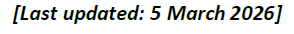
Last updated:16 Mar 2026
Summer 2026
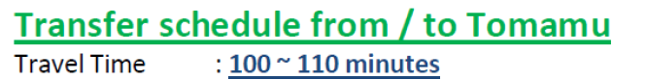
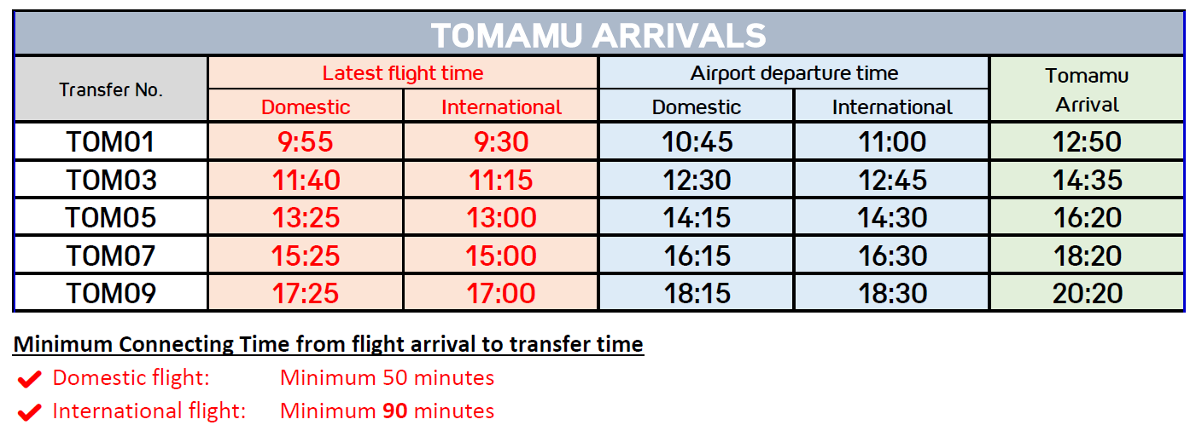
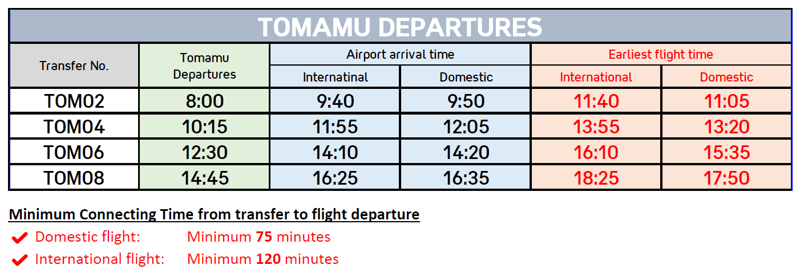

Please note:
- Collective transfers do not operate daily; they run only when there are existing bookings.
- Requests made close to the travel date may be declined due to limited availability.
- Collective transfer schedules do not cover all flight times.
- As the service operates on fixed schedules, guests may need to wait at CTS Airport upon arrival. Immediate departure is not guaranteed.
- The type of vehicle used (bus or taxi) will be determined based on the number of guests.
- Child seats cannot be provided for collective transfers.
- If you have booked transfers, please update your flight details in your Customer Account at least 6 days before arrival. Failure to provide flight details may result in the inability to secure the collective transfer service.

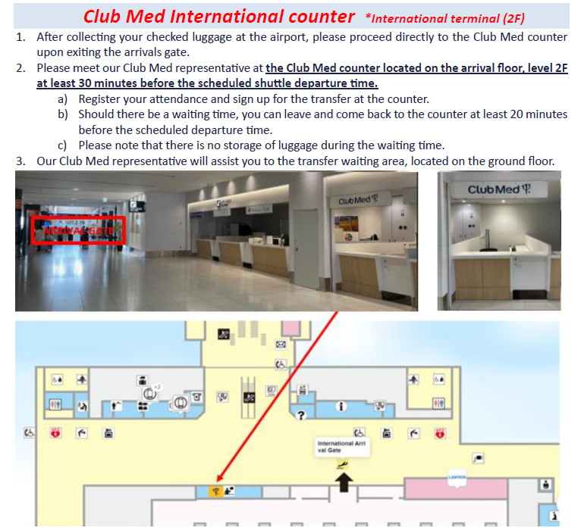

*If GM uses the train, the station is located underground floor the domestic terminal.
*The Club Med airport staff is operated by Rryoko-Soken.
For GM whose flight arrival and bus transfer dates are different (stop over etc.), please meet at the Tour Counter (Club Med shared counter) at the Domestic Terminal(1F) at least 30 minutes before transfer departure time.

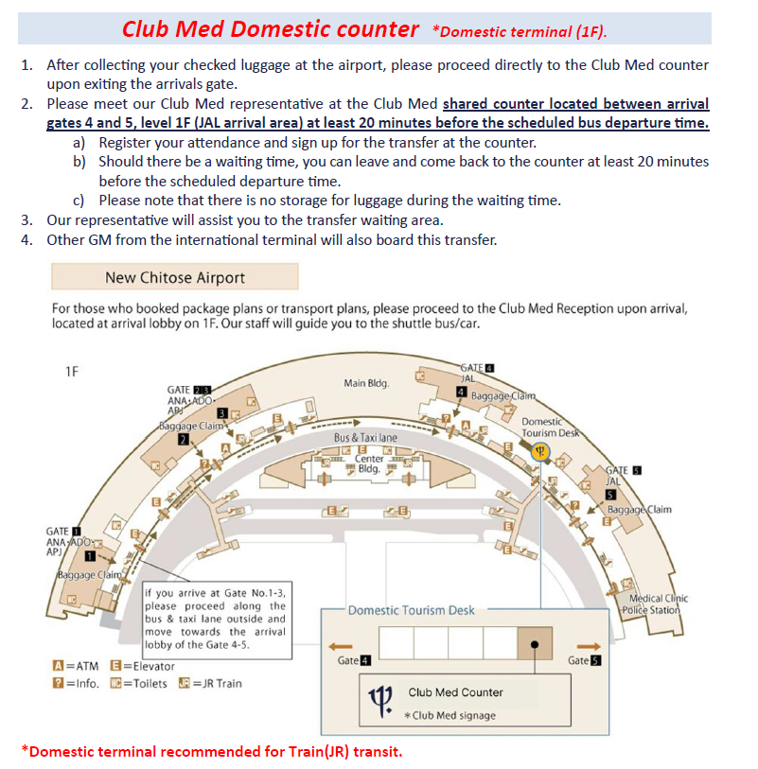

For GM whose flight arrival and bus transfer dates are different (stop over etc.), please meet at the Tour Counter (Club Med shared counter) at the Domestic Terminal(1F) at least 30 minutes before transfer departure time.

